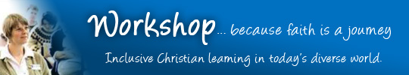

galilee

Workshop is a course in Applied Christian Studies. It has been running in major cities in England since 1983. Well over 4,000 people have completed the course so far.
North East Workshop is now being offered at Stockton Riverside College Sports Centre, Marsh House Avenue, Billingham TS23 2HB from 10.00 a.m. to 6.00 p.m. one Saturday a month over two years. This will be our fifth cycle.
Most people who enrol on Workshop are already on a faith journey of their own (which may not be the same as going to church), and are ready to think seriously about what they believe. The course is unusual in being both radically Christian and inclusive, drawing on a variety of traditions from conservative to liberal, from activist to contemplative, from Anglican to Anabaptist.
- Some Workshop students have higher degrees, others left school with few qualifications.
- Some are theologically conservative, others are free-thinkers.
- Some are church leaders, others may be “de-churched” (‘off church’ but not ‘off God’).
- Some come purely for their own spiritual development, others go on to further theological study.
- But they all want to engage seriously with faith issues for themselves.
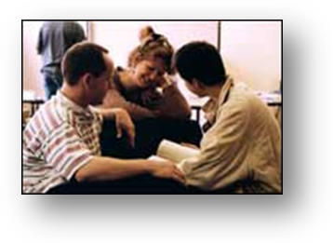
Workshop is for adults, and is pitched at level 3 or 4 (about A-level). There is a fully validated qualification at level 3 for those who choose to enrol on it.
You can find out more about the national Workshop course (based in London) at www.workshop.org.uk.
For comments from former students and academics, go to www.workshop.org.uk/whatpeoplesay.
Cost: Suggested donation of £12 per Saturday. If you pay tax and would like to complete a Gift Aid form, Galilee Network will be able to reclaim the tax. If you would like to do the course but £12 is too much, just pay what you can. We want people to do the course, even if they cannot pay anything towards the costs.
Location: SRC Sports Centre, Marsh House Avenue, Billingham TS23 3HB
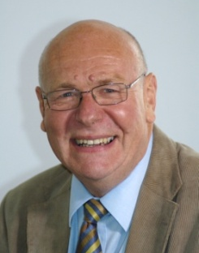
To enquire about the course, or to enrol, contact the course tutor, Paul Wilson at ptswilson@yahoo.co.uk or 07722 983888 or via the website www.neworkshop.co.uk or by post to NEWorkshop, 17 Richmond Crescent, Billingham TS23 2JP or complete the application form on the back page.
A native of Teesside, Paul has been in education all his life, mostly at Bede Sixth Form, Billingham. He has taught on Workshop in all the national centres, and on Advanced Workshop in Birmingham, and is an associate tutor with Lindisfarne RTP. He has master’s degrees in Mathematics and Theology and has been involved in church planting and leadership for over 30 years. He is married with 3 children and 5 grandchildren.
Workshop Programme 2013-14
Salvation Landscape    the Hebrew Story | Saturday 14th September 2013 | Primeval Skyline  Creation stories and the Genesis narratives  Wilderness and Hill Country  From the Exodus to the period of the Judges  Mountain and Plain  From the rise of the Monarchy to the division of the Kingdom
 | Saturday  12th October  2013 | Thunder and Cyclone  Hebrew prophets and the destruction of Israel  Lightening and Tempest  Exile and return  The Overview  What is the storyline of the Bible?
Scrolls and Parchments  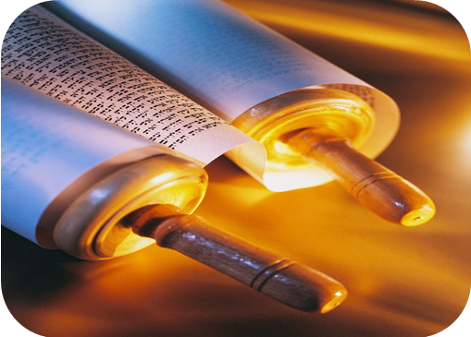  the Hebrew Scriptures | Saturday  9th November 2013 | Shape and Structure  The Formation of the Jewish Bible  Essential Skills  The art of interpreting the Hebrew Scriptures  Torah and Covenant  Traditions that weave Israel’s foundations
 | Saturday  7th December 2013 | Prophecy and Vision  Understanding the texts that interpret the times  Poetry and Wisdom  The rhythms and creativity of the Hebrew heart and mind  Visions and Symbols  The world of Jewish apocalyptic writings
Re-Imagining Hope    living at the edge of time | Saturday  11th January 2014 | The Vision  Shalom/wholeness: the panorama of biblical hope  The Challenge  Mishpat/judgment: the impact of biblical hope  The Kingdom  Jesus and the future breaking in ahead of time
 | Saturday  8th February  2014 | The End  Parousia and resurrection  The Climax  Final judgment and eternal destiny  Questions  A conversation around the theme of hope
Stories and Letters    the New Testament | Saturday  8th  March  2014 | Shape and Structure  The formation of the Christian Scriptures  Essential Skills  The art of interpreting the New Testament  Gospel and Messiah  Four distinct portraits, one historical Jesus
 | Saturday  5th  April  2014 | Parable and Miracle  Communication by words and power  Apostle and Epistle  Bringing the genius of the gospel to the world  Dreams and Images  Exploring the imagination of Revelation
Spirituality   | Saturday  10th  May  2014 | Way of the Spirit  Spiritual growth and development  Prayer and Meditation  The heart of communion with God  Discernment  Practice and purpose of hearing God
Mission & Compassion    expressing love and truth | Saturday  7th  June  2014 | Jesus at the Centre  Seeking a Christ-centred faith  Mission after Christendom  Mission from the margins of society  Mission after Modernity  Post-modern thinking and today’s mission
 | Saturday  5th  July  2014 | Good News to the Poor  Serving and learning from those in greatest need  Loving and Confronting  Helping hurting people find wholeness  Physical Healing  Hard questions about medicine, miracles and sickness
Workshop Programme 2014-15
Quest & Questioning    real challenges, faith choices | Saturday  13th  September  2014 | Scripture on Trial  The nature and reliability of the biblical text  Science & Faith  ‘How’ and ‘why’ are both essential questions in finding truth  God & Creation  Scripture and science: two stories that explore one reality
 | Saturday  11th  October  2014 | The Existence of God  Reflection on the classical and current debates  The Problem of Evil  Facing objections to a belief in a God who is good  Spiritual Experience  Seeking clarity within the mystery of sacred encounter
Credible or Incredible?    Christian belief put to the test | Saturday  8th  November  2014 | The Light  Natural, biblical and personal revelation  The Godhead  The tri-unity of God’s self-revelation  The Image  Human personhood as a physical and spiritual totality
 | Saturday  6th  December  2014 | The Incarnation  Jesus Christ – fully human, fully divine  The Atonement  Images and understandings of the death of Jesus  The Resurrection  The resurrection of Jesus in history and theology
Peace and Power    being vocal, political & spiritual | Saturday  10th  January  2015 | Peace and Wholeness  Shalom as the basis for ethical action  Gospel of Peace  Evangelism as the proclamation of God’s shalom to all  Companions with Creation  Understanding the gospel as deep green
 | Saturday  7th  February  2015 | Church and State  The nature of the state and the Christian response within it  Crime and Justice  What does it really mean to put things right?  Peace and War  The challenge of ‘just war’ and non-violence
Body and Soul    living, believing and behaving | Saturday  7th  March  2015 | Spirit and Freedom  Life in the Spirit as the source of ethical living  Truth and Values  Values-based Christian ethics  Living Towards Believing  Seeking the choices that point towards truth
 | Saturday  11th  April  2015 | Sex, Gender and Difference  The diversity of human gender identity  Sex, Orientation and Debate  Questions, experience and homosexuality  Sex, Singleness and Marriage  Exploring human sexual relationships
One World, Many Faiths   | Saturday  9th  May  2015 | Foundations  Fears and questions, culture and worldviews  Common ground  Shared values between faiths  Uniqueness of Jesus  Examining the inclusive/exclusive claims of the Christian faith
Living Community    church - local, global & radical | Saturday  6th  June  2015 | Finding Focus  Being Jesus-people in a cynical and turbulent world  Image and Expression  Biblical pictures and historical examples  Ways of being church  Examples from today’s world
 | Saturday  4th  July  2015 | Water of Life  Spirituality, community and baptism  Spirit of Life  Where the Spirit of the Lord is, there is freedom  Bread of Life  The Christian foundation of breaking bread

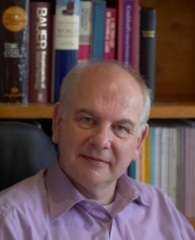
This course has made available resources for a quality of education and training which local congregations are rarely able to supply from within themselves. For some it has been an appropriate stepping stone for work at degree level. Participants speak of the quality of the materials produced, and the creative ways in which communication takes place. I have been impressed by the rigour and professionalism of the course in all respects.
Workshop
Advisory
Committee

Rev Dr Nigel Wright, Principal, Spurgeon’s College, London
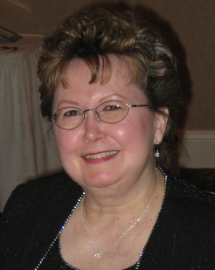
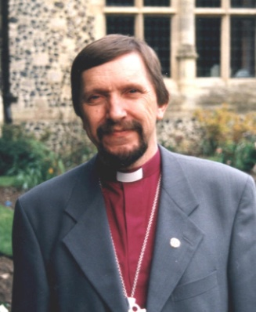
The course has benefitted numbers of our 1400 staff and volunteers as well as others within the organisations and churches we partner. Its in-service style suits those with busy lives. There is a strong emphasis on spirituality and personal development. The course considers major ethical issues, relevant social action and world culture, all important in the twenty-first century.

Fran Beckett, Chief Executive, Church Urban Fund
Rt Rev Graham Cray, Director of Fresh Expressions
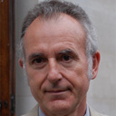
"The course is a welcome academic innovation providing ecumenical and academic access to higher education. I can pay the course no higher praise than saying that I would treat the qualification as seriously as an ordination certificate from a reputable seminary."

Prof. Andrew Walker: Director of MA in Theology and Education, King’s College, London
"I have been enormously impressed with the calibre of the students, the quality of the curriculum, the ability of the various lecturers, and the clear application that the students seem to be able to make in terms of the content of the course. Past students frequently tell me how helpful the programme was in developing their potential."
Rev Dr Martin Robinson: Director of Together in Mission, Springdale College, Birmingham
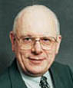
"An excellent course. It is simply written, brilliantly presented and found to be helpful by the many thousands who have already attended it. Rigorously honed, it ensures its elements are relevant, interesting and up to date. This particular course is of an exceptionally high standard and is especially worthwhile."
Dr Peter Brierley: Executive Director, Christian Research
-------------------------------------------------------------------------------------------------------------------------
WORKSHOP Application Form 2013-14

Name ....................................................................... Date of birth .........................................
Address .....................................................................................................................................
Post Code ............................... Phone .....................................Mobile ……..……………..……
Email ....................................................... Church (if any) .........................................................
Education (highest qualification you have gained) ....................................................................
Please post to NEWorkshop
17 Richmond Crescent
Billingham TS23 2JP
Or use the online form at
www.neworkshop.co.uk/to-enrol.php.
Please put a cross beside whichever apply to you: | X
I would like to discuss the suitability of the course
I would like to meet last year’s students
I want to enrol on the whole course.
I would like to come to some Saturdays, but not all
Any questions or comments?

